Housing WBS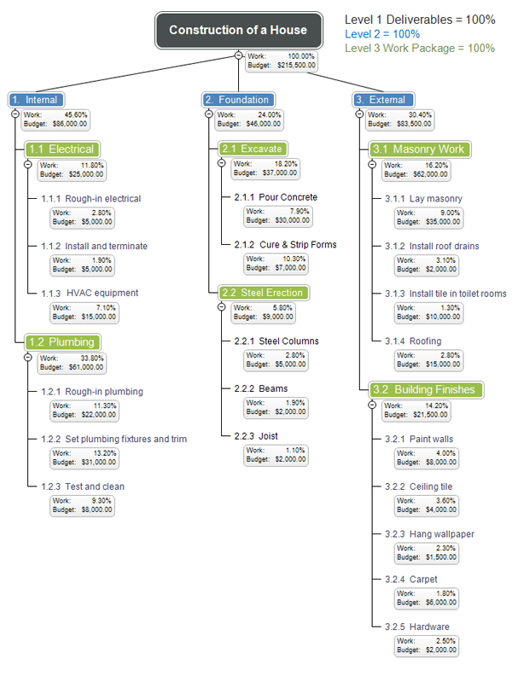

Construction of 10 Shelters